आज की दुनिया का हाल तो हम सभी जानते ही है,
सबको या तो डॉक्टर, या engineer बनना है,
सब college तो यही सोचकर पहुंचते हैं,
ऐसे पैसे ही पैसे अब तो बेस पैसे कमाने है पर असलीयत तो किसी को पता ही नहीं है।
सब यही बोलते है, एक अच्छे college में पहुँच जाओ,
Job तो अच्छी लग ही जाएगी।.

तो चलिए आज देख ही लेते है।
किस college की placement में है कितना दम,
क्या आज के समय में सिर्फ CS ही बचा है अच्छी Job पाने का माध्यम,
या फिर फिर ये तो है आपका एक भ्रम ।

किस college पर रही Google, Zomato, Infosys की मेहरबानी
और किस college के उक न लगने की बात छुपानी,
क्या सिर्फ को पड़ी अपने घर वालों से IIT, Harvard, NLU, Christ से अच्छी Job लगी है,
या बाकी college भी दिखा रहे है अपनी placement at उच्चसत्रीय क्रम ।.

आज तो फैसला हो ही जाए,
किस college में है कितना दम,
और कौन किसके सामने है पानी कम ।

CERTIFICATE

This is to certify that Yanik Kumar a student of Class: XII A has successfully completed his Informatics Practices (065) software project as per the curriculum 2025-26 on ‘Job Placement in Various Colleges Analysis Software Development’ with my team member: –
1. Aditi Negi
under the guidance of Ma’am Vineeta Robert Simon.

Internals’ Signature External’s Signature School Stamp

ACKNOWLEDGEMENT

I would like to express my special thanks and gratitude to my Informatics Practices Teacher Ma’am Vineeta Robert Simon who gave me and my team the instructions and guidance to complete this software development project.
I would also like to extend my gratitude to my parents for providing me with all the facilities that were required.

____________________
YANIK KUMAR

INDEX
S. No. | Topic | Page No. | Teacher's Remarks

PROJECT SYNOPSIS

This survey analysis briefly talks about the job placement of various colleges of all fields and from around the world. Through this project he, the user can find out more details about the placement percentage, highest package obtained, top companies visiting the college. Also, this report will help the aspirants to go through the above data of the colleges they are targeting. This will help them make a better decision and finally choose the most appropriate colleges. This analysis can also be used to rank the colleges adhering to various criteria. The project is coded as a user-friendly interface so that the user can easily find out all the information, he/she wants.

OBJECTIVES

1. To gather the data from reliable sources
2. To save and store data in an electronic format
3. To secure data in terms of consistency
4. To understand the need of the users and what actually are they looking in this sector
5. To make a perfect analysis of the data using the Python coding
6. To design the code to best suit the needs of the user and the optimum utilization of the data.
7. To execute the code at various stages of programming
8. To ensure the software if error free by testing and trial
9. To get a review among a sample user of this sector
10. To document the entire stages of this software development

PROJECT METHOD
The Waterfall Model is also referred to as a linear-sequential life cycle model.
The waterfall Model illustrates the software development process in a linear sequential flow. This means that any phase in the development process begins only if the previous phase is complete. In this waterfall model, the phases do not overlap.
The following illustration is a representation of the different phases of the Waterfall Model.
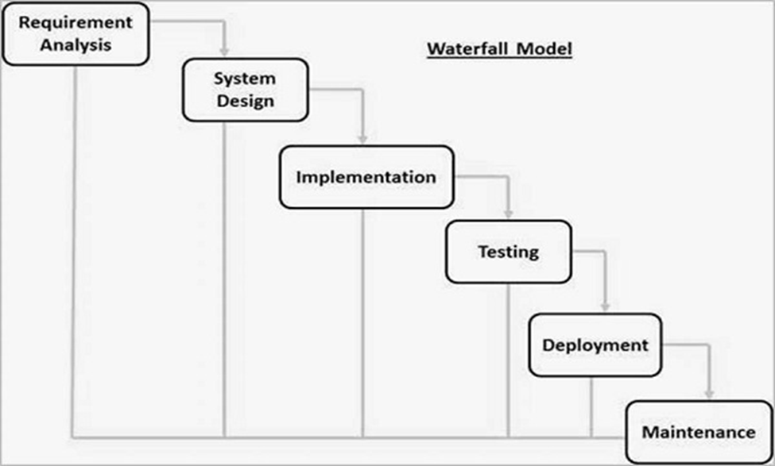
The sequential phases in Waterfall model are −
· Requirement Gathering and analysis − All possible requirements of the system to be developed are captured in this phase and documented in a requirement specification document.
· System Design − The requirement specifications from the first phase are studied in this phase and the system design is prepared. This system design helps in specifying hardware and system requirements and helps in defining the overall system architecture.
· Implementation − With inputs from the system design, the system is first developed in small programs called units, which are integrated in the next phase. Each unit is developed and tested for its functionality, which is referred to as Unit Testing.
· Integration and Testing − All the units developed in the implementation phase are integrated into a system after testing of each unit. Post integration the entire system is tested for any faults and failures.
· Deployment of system − Once the functional and non-functional testing is done; the product is deployed in the customer environment or released into the market.
· Maintenance − There are some issues which come up in the client environment. To fix those issues, patches are released. Also to enhance the product some better versions are released. Maintenance is done to deliver these changes in the customer environment.
All these phases are cascaded to each other in which progress is seen as flowing steadily downwards (like a waterfall) through the phases. The next phase is started only after the defined set of goals are achieved for previous phase and it is signed off, so the name "Waterfall Model". In this model, phases do not overlap.
Waterfall Model - Application
Every software developed is different and requires a suitable SDLC approach to be followed based on the internal and external factors. Some situations where the use of Waterfall model is most appropriate are −
· Requirements are very well documented, clear and fixed.
· Product definition is stable.
· Technology is understood and is not dynamic.
· There are no ambiguous requirements.
· Ample resources with required expertise are available to support the product.
· The project is short.
Waterfall Model - Advantages
The advantages of waterfall development are that it allows for departmentalization and control. A schedule can be set with deadlines for each stage of development and a product can proceed through the development process model phases one by one.
Development moves from concept, through design, implementation, testing, installation, troubleshooting, and ends up at operation and maintenance.
Some of the major advantages of the Waterfall Model are as follows –
· Simple and easy to understand and use
· Easy to manage due to the rigidity of the model. Each phase has specific deliverables and a review process.
· Phases are processed and completed one at a time.
Works well for smaller projects where requirements are very well understood.
· Clearly defined stages.
· Well understood milestones.
· Easy to arrange tasks.
· Process and results are well documented.

Waterfall Model - Disadvantages
The disadvantage of waterfall development is that it does not allow much reflection or revision. Once an application is in the testing stage, it is very difficult to go back and change something that was not well-documented or thought upon in the concept stage.
The major disadvantages of the Waterfall Model are as follows −
· No working software is produced until late during the life cycle.
· High amounts of risk and uncertainty.
· Not a good model for complex and object-oriented projects.
· Poor model for long and ongoing projects.
· Not suitable for the projects where requirements are at a moderate to high risk of changing. So, risk and uncertainty are high with this process model.
· It is difficult to measure progress within stages.
· Cannot accommodate changing requirements.
· Adjusting scope during the life cycle can end a project.
· Integration is done as a "big-bang. at the very end, which doesn't allow identifying any technological or business bottleneck or challenges early.

CODE FLOW

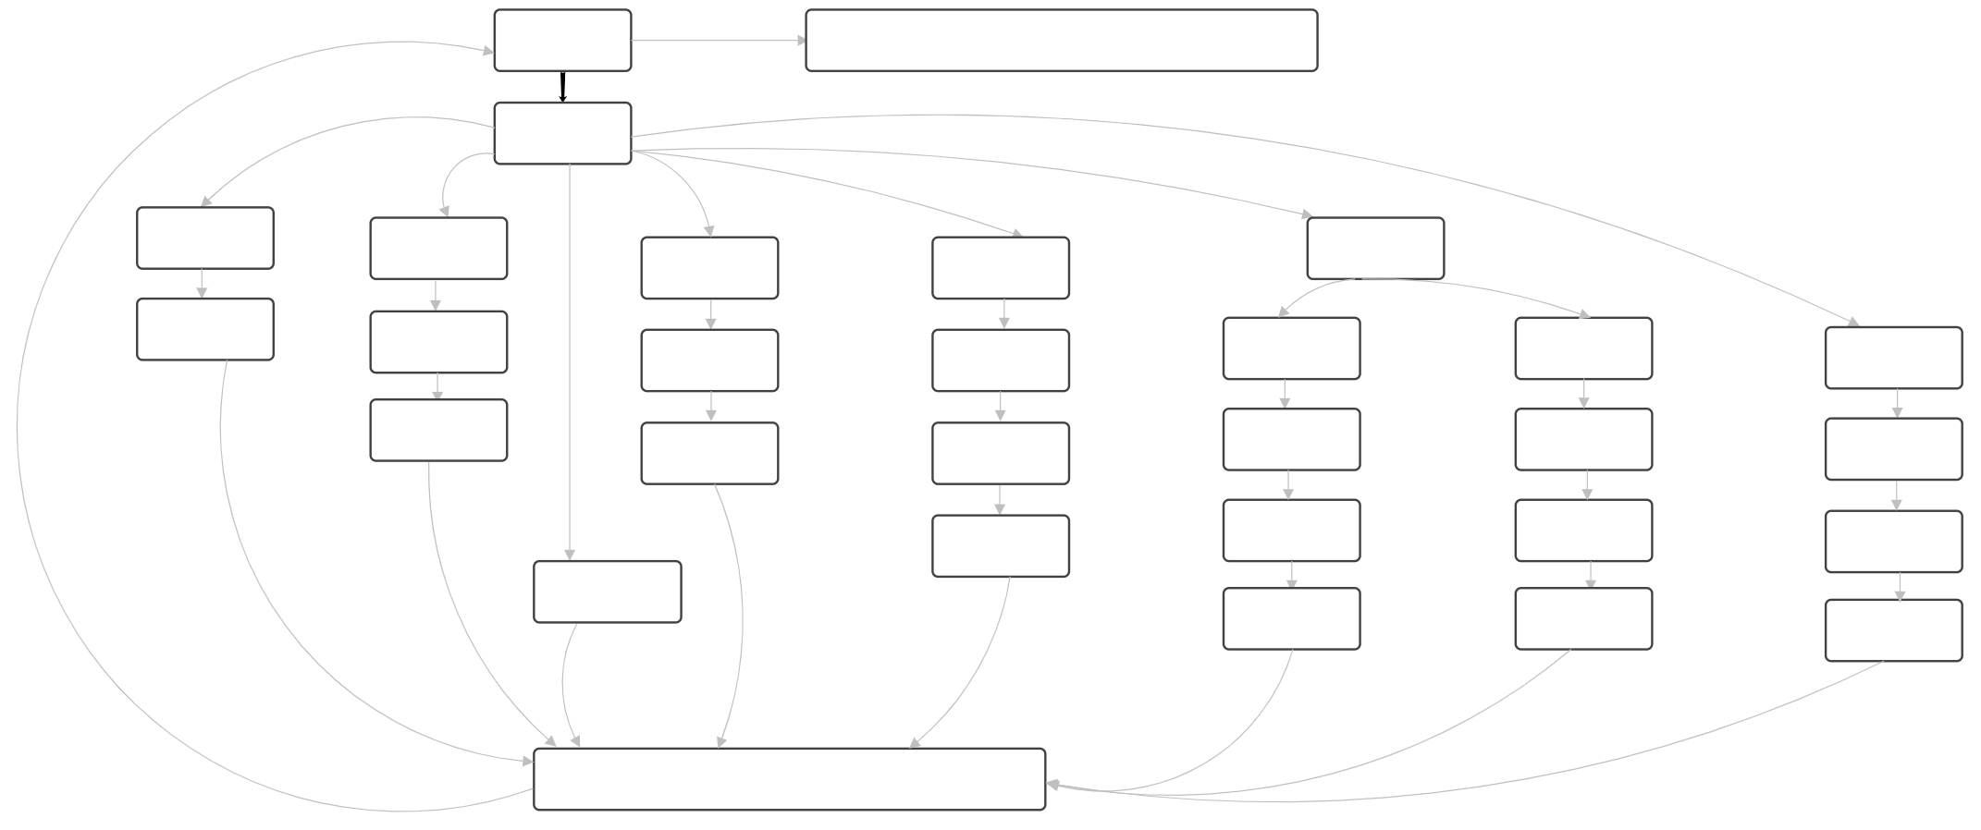
PROJECT REQUIREMENT ANALYSIS

User’s Needs
1. To understand the data pattern
2. To predict the nature and behaviour of the current data design
3. To get ideas and suggestions to reroute the data in favourable behaviour
4. To get solutions for the current pattern of data for the desired result.
Software Requirement
Software requirement is done by several methods available. Which helps to understand the exact need of the kind of software required to run the software and to achieve the desired solution.

PROJECT IMPLEMENTATION

Operating Environment: Windows
System S/w Specs: Python
User Interface requirements
UI is an important part of any software or hardware or hybrid system. A software is widely accepted if it is -
- easy to operate
- quick in response
- effectively handling operational errors
- providing simple yet consistent user interface
__________________________________________________
Data Collection Procedure
Data collection is defined as the procedure of collecting, measuring and analysing accurate insights for research using standard validated techniques. A researcher can evaluate their hypothesis on the basis of collected data. In most cases, data collection is the primary and most important step for research, irrespective of the field of research. The approach of data collection is different for different fields of study, depending on the required information.
The most critical objective of data collection is ensuring that information-rich and reliable data is collected for statistical analysis so that data-driven decisions can be made for research.
Web/Online
Pros: Cheap, can self-administer, very low probability of data errors
Cons: Not all your customers might have an email address/be on the internet, customers may be wary of divulging information online.
__________________________________________________
Data Analysis Procedure
Once we had set out to collect data for analysis, we were overwhelmed by the amount of information to make a clear, concise decision. With so much data to handle, we need to identify relevant data for your analysis to derive an accurate conclusion and make informed decisions.
The following simple steps helped us identify and sort the data for analysis.
- Organizing the data and making sure to add side notes, if any.
- Cross-checking data with reliable sources.
- Converting the data as per the scale of measurement as defined earlier.
- Excluding irrelevant data.

Data Analysis
- Once collected the data, perform sorting, plotting, and identifying correlations.
- Manipulating and organizing the data.
- To be prepared, if need be, then to traverse the steps again from the beginning.
- If need be, then to redefine parameters, and reorganize data.
- Making use of the different tools available for data analysis.
__________________________________________________
Infer and Interpret Results
- Review whether all parameters have been considered and taken into coding application for making the decision
- Review if there is any hindering factor for implementing the decision.
- Choose data visualization techniques to communicate the message better.
- Applying added visualization techniques colour coding, elements, graphs detailed and more.
Since, it is only a hypothesis. Real-life scenarios may always interfere with our results. In Data Analysis, there are a few related terminologies that identity with different phases of the process.

1. Data Mining
This process involves methods in finding patterns in the data sample.
2. Data Modelling
This refers to how an organization organizes and manages its data.
__________________________________________________
Data Analysis Techniques
There are different techniques for Data Analysis depending upon the question at hand, the type of data, and the amount of data gathered. Each focuses on taking onto the new data, mining insights, and drilling down into the information to transform facts and figures into decision-making parameters. Accordingly, the different techniques of data analysis can be categorized as follows:
1. Techniques based on Mathematics and Statistics
- Descriptive Analysis: Descriptive Analysis considers the historical data, Key Performance Indicators and describes the performance based on a chosen benchmark. It takes into account past trends and how they might influence future performance.

- Dispersion Analysis: Dispersion in the area onto which a data set is spread. This technique allows data analysts to determine the variability of the factors under study.
- Regression Analysis: This technique works by modelling the relationship between a dependent variable and one or more independent variables. A regression model can be linear, multiple, logistic, ridge, non-linear, life data, and more.
- Factor Analysis: This technique helps to determine if there exists any relationship between a set of variables. This process reveals other factors or variables that describe the patterns in the relationship among the original variables. Factor Analysis leaps forward into useful clustering and classification procedures.
- Discriminant Analysis: It is a classification technique in data mining. It identifies the different points on different groups based on variable measurements. In simple terms, it identifies what makes two groups different from one another; this helps to identify new items.
- Time Series Analysis: In this kind of analysis, measurements are spanned across time, which gives us a collection of organized data known as time series.

2. Techniques based on Visualization and Graphs
- Column Chart, Bar Chart: Both these charts are used to present numerical differences between categories. The column chart takes to the height of the columns to reflect the differences. Axes interchange in the case of the bar chart.
- Line Chart: This chart represents the change of data over a continuous interval of time.
- Area Chart: This concept is based on the line chart. It also fills the area between the polyline and the axis with colour, representing better trend information.
- Pie Chart: It is used to represent the proportion of different classifications. It is only suitable for only one series of data. However, it can be made multi-layered to represent the proportion of data in different categories.

CODE

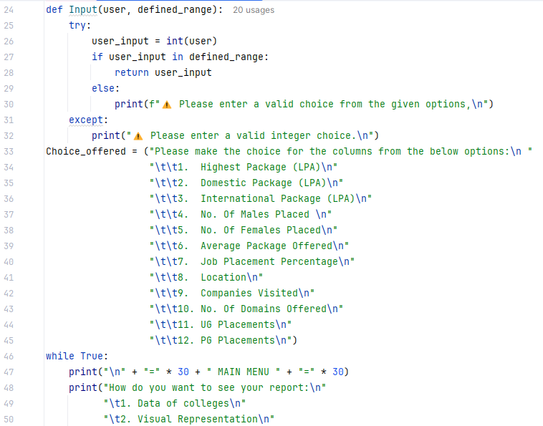
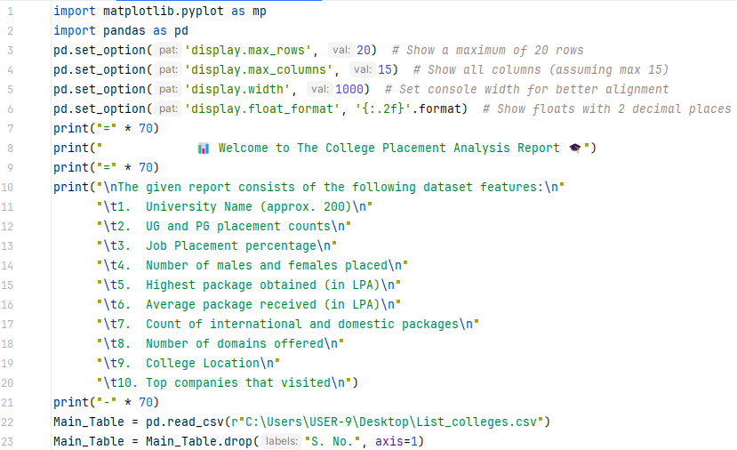
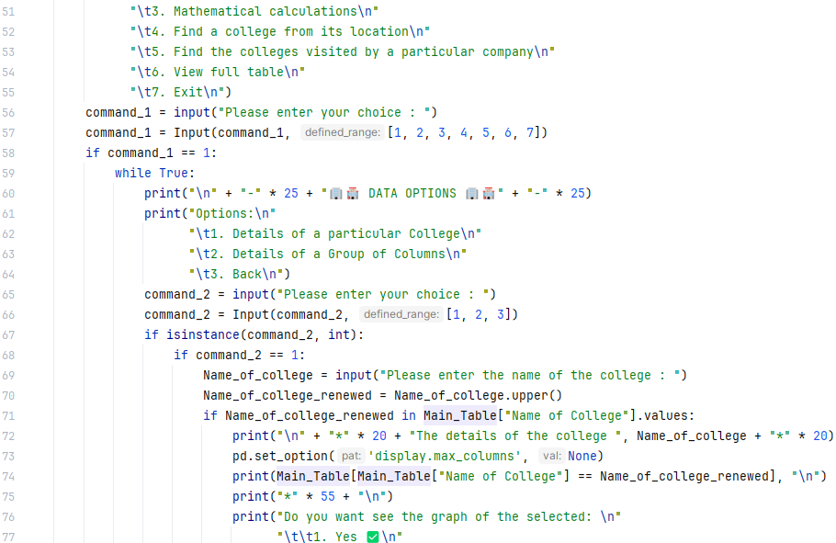
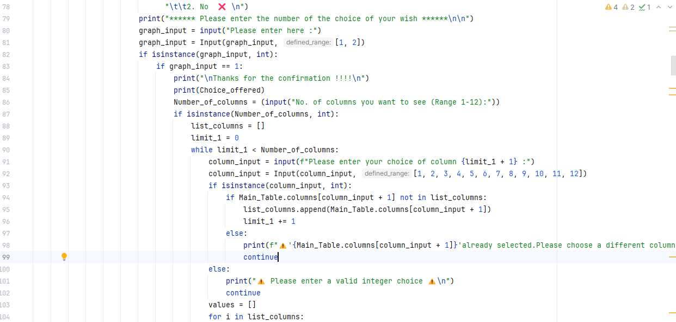
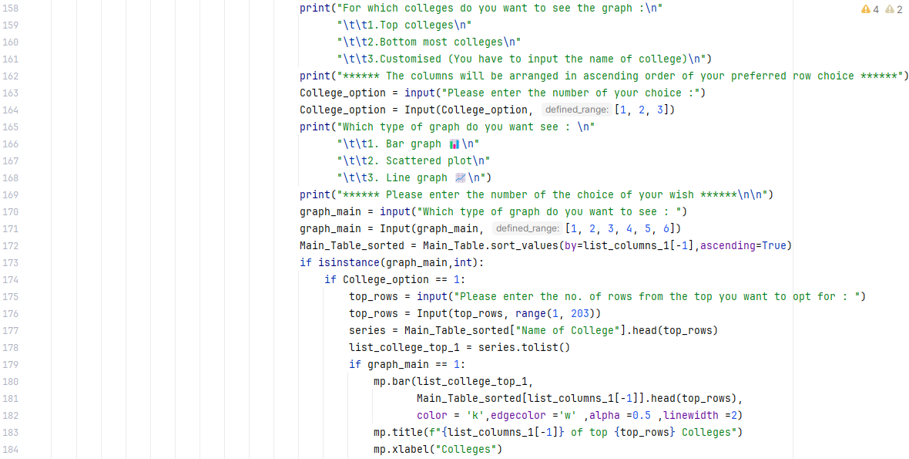
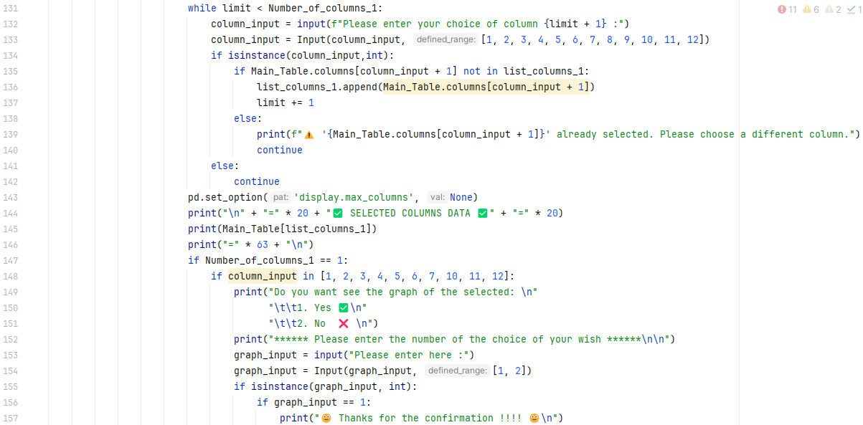
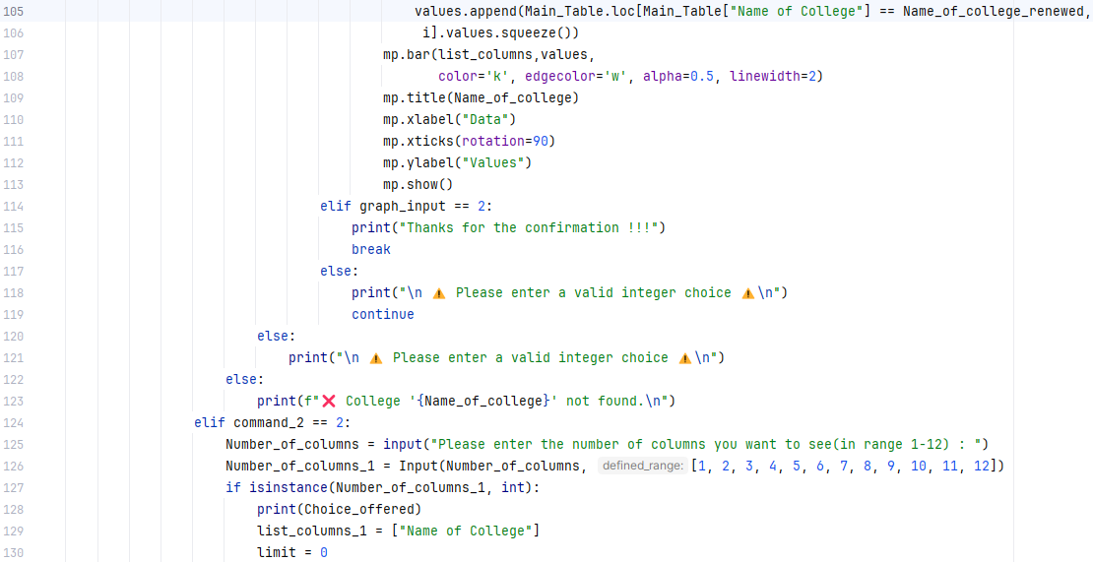
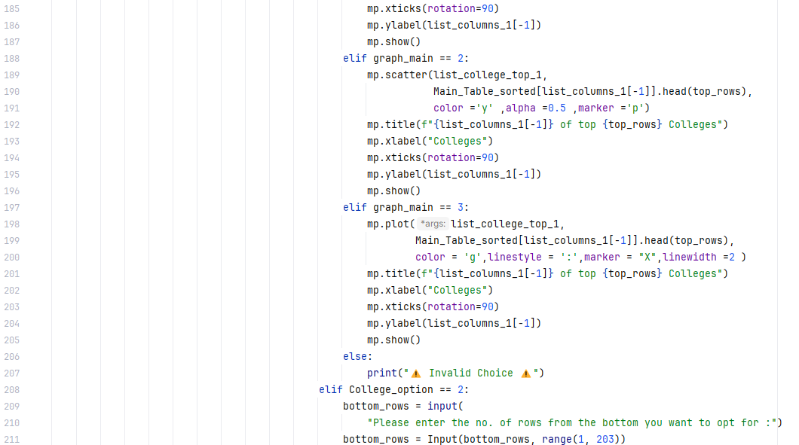
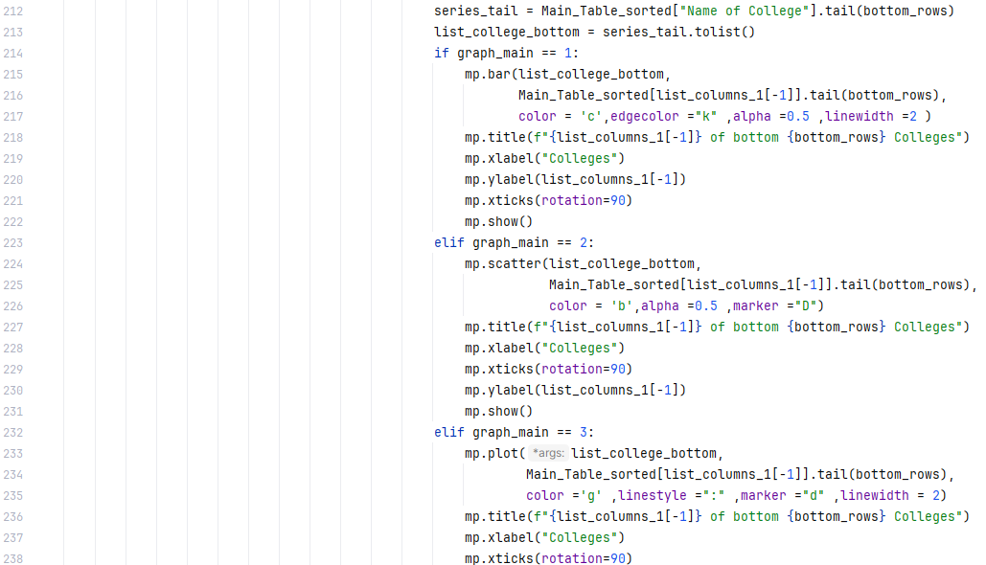
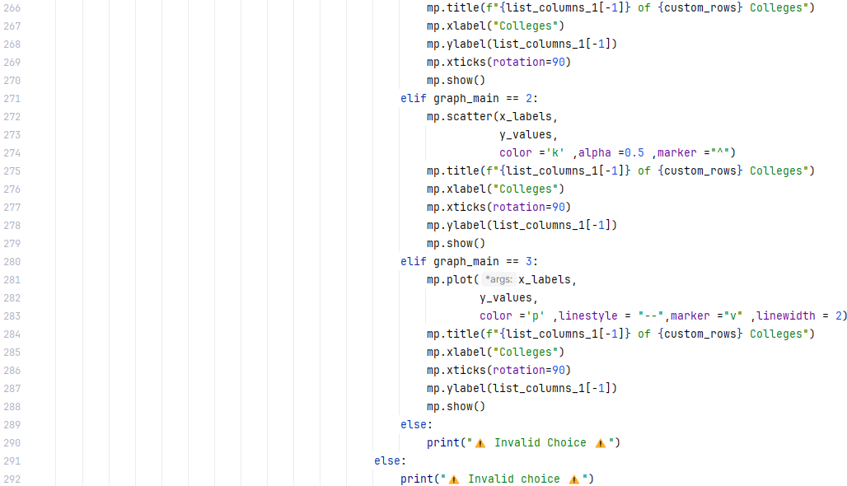
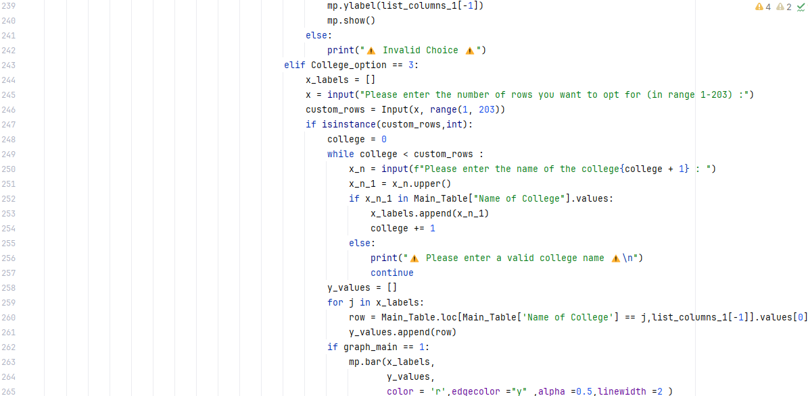
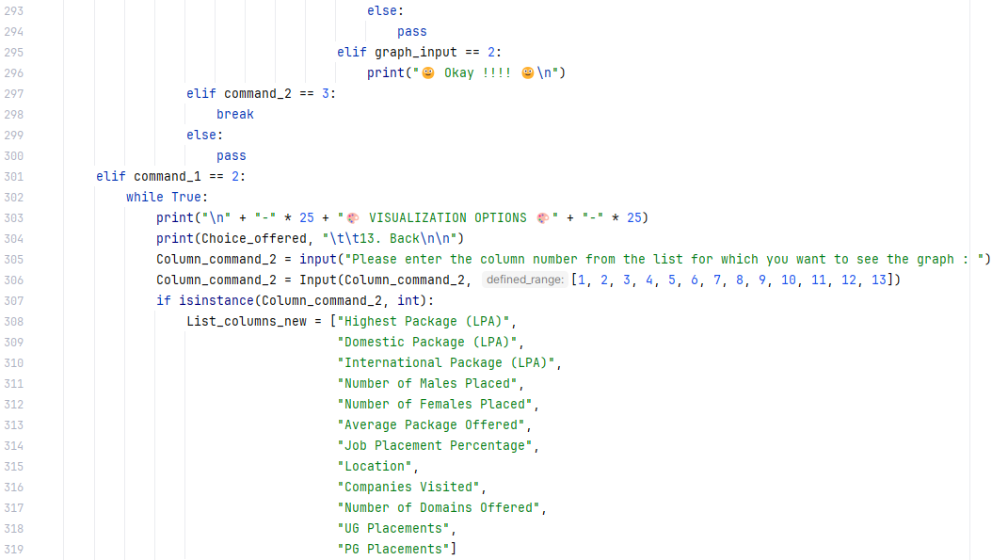
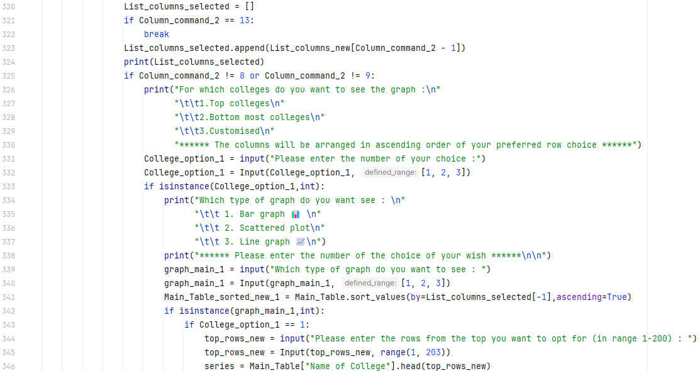
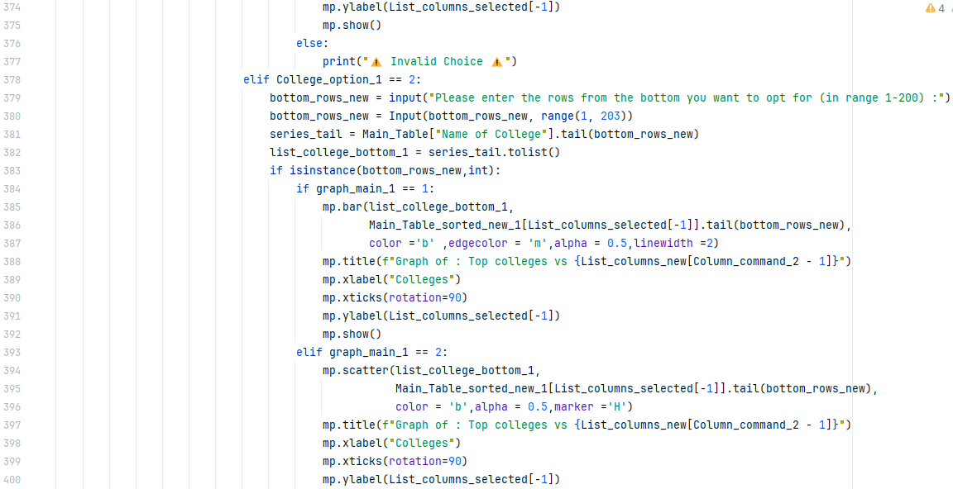
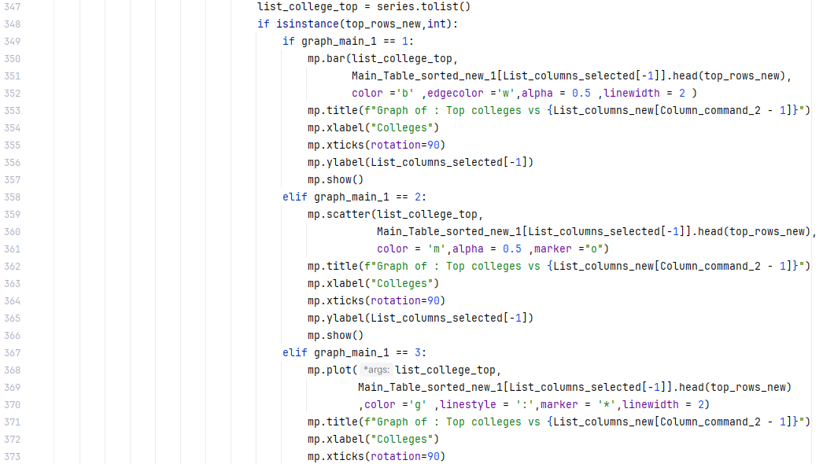
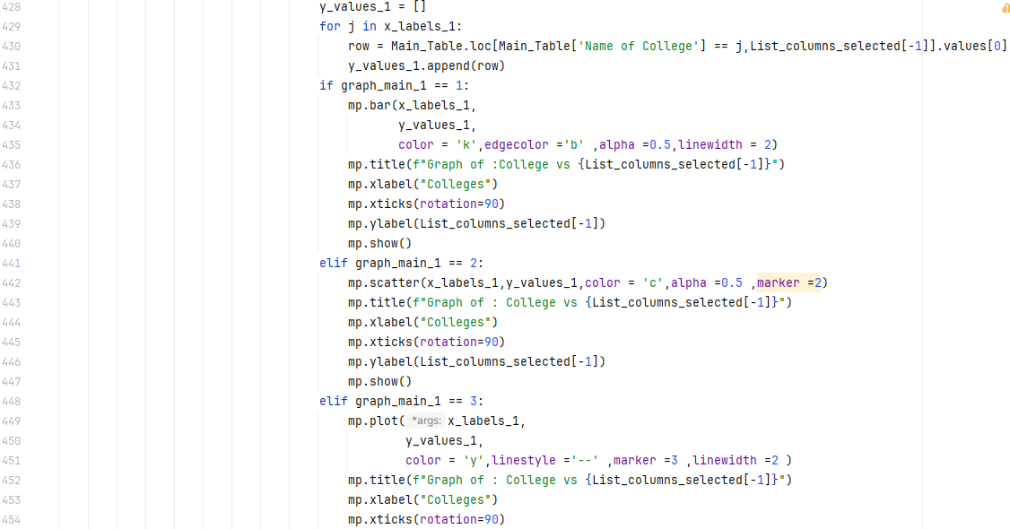
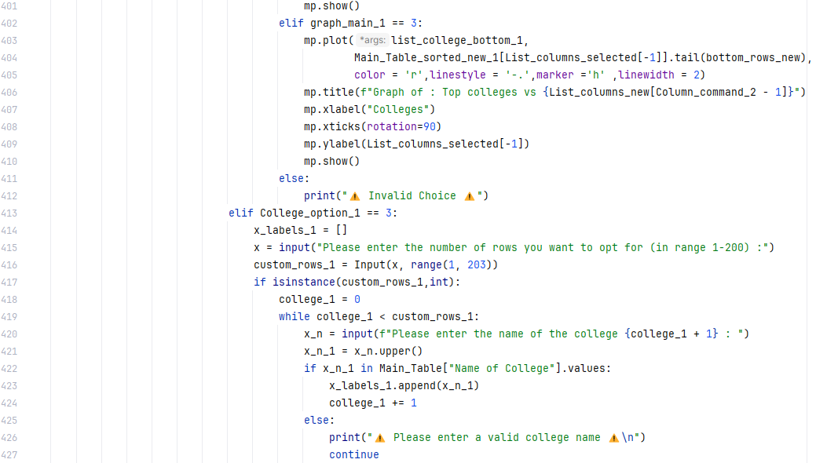

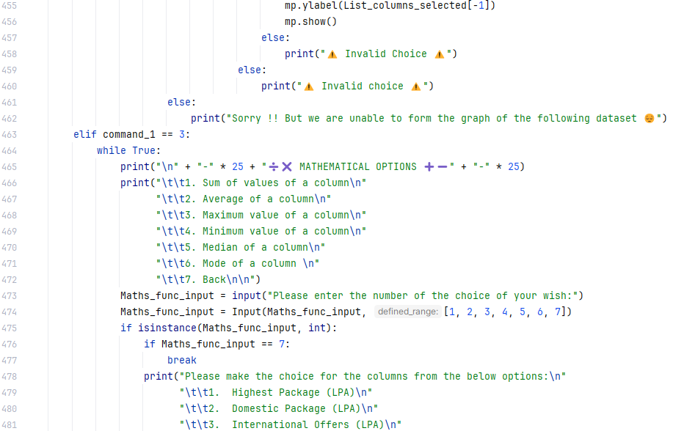
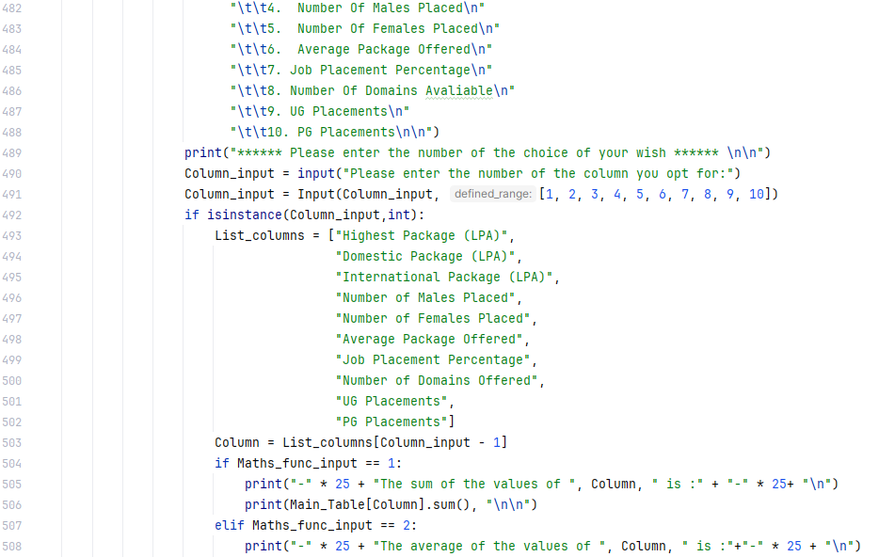
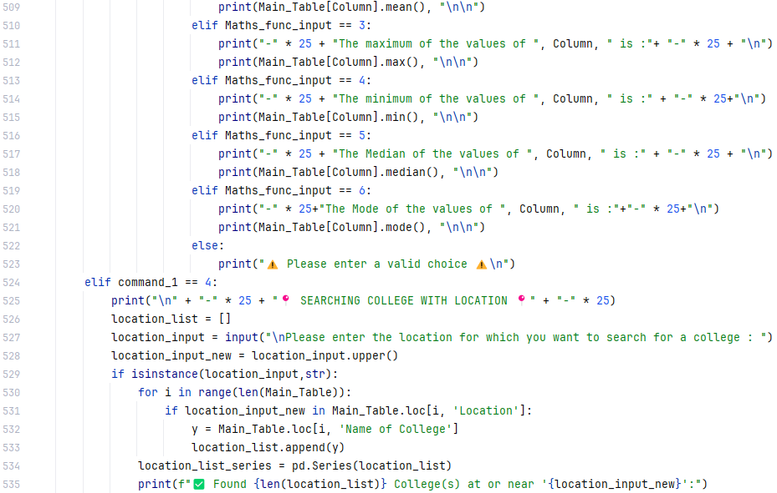
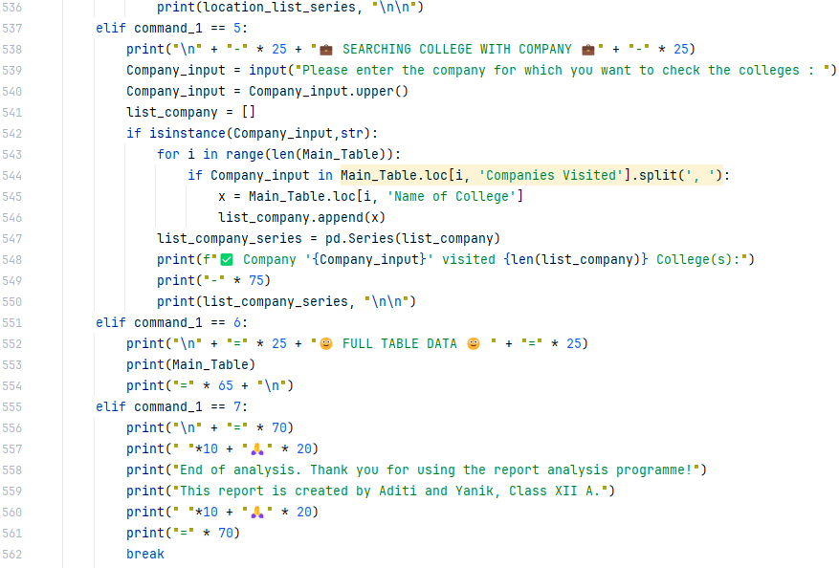

OUTPUT

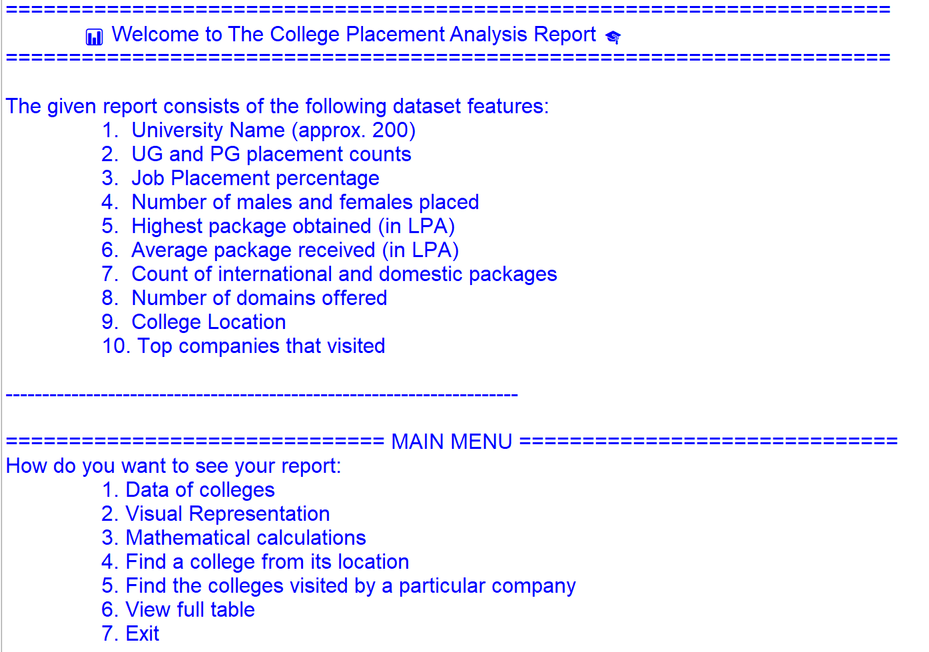
Visual Representation
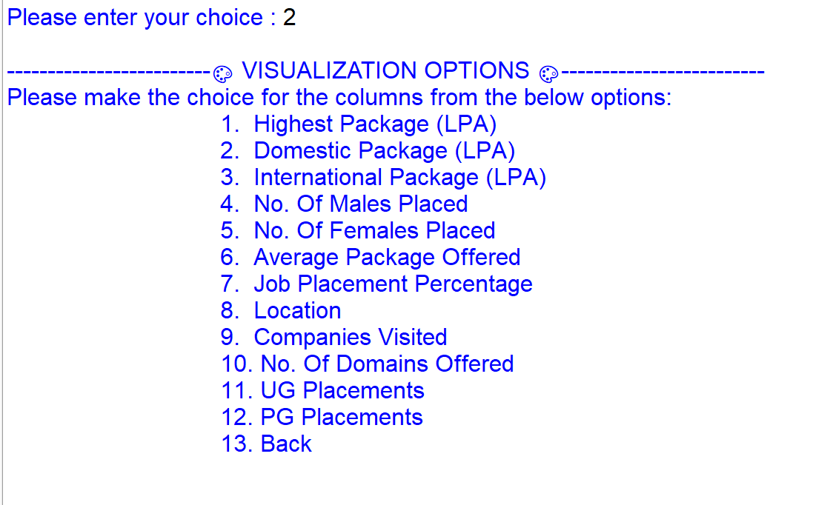
- Graph 1
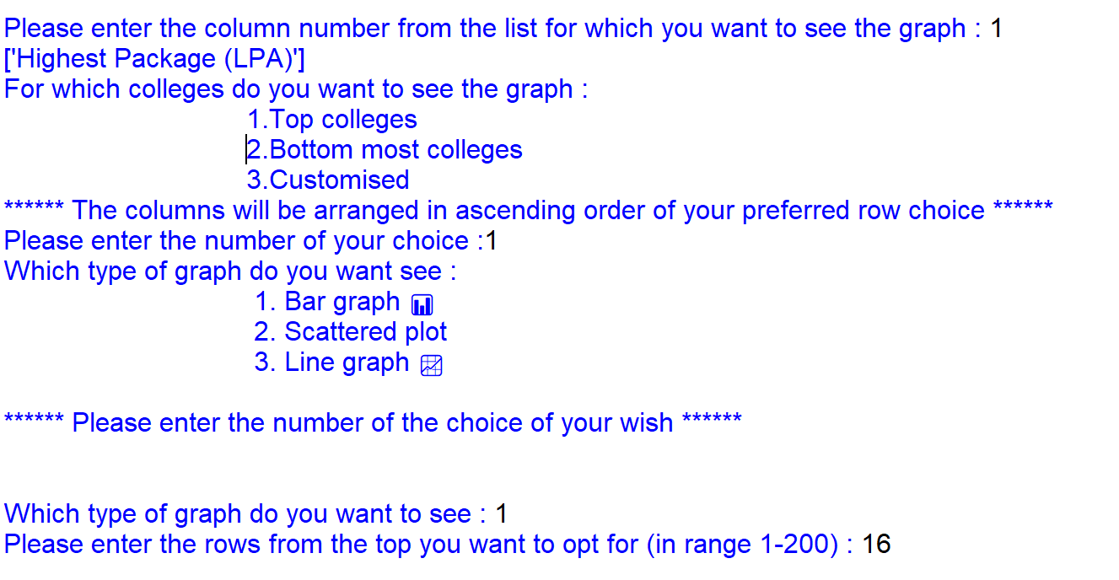
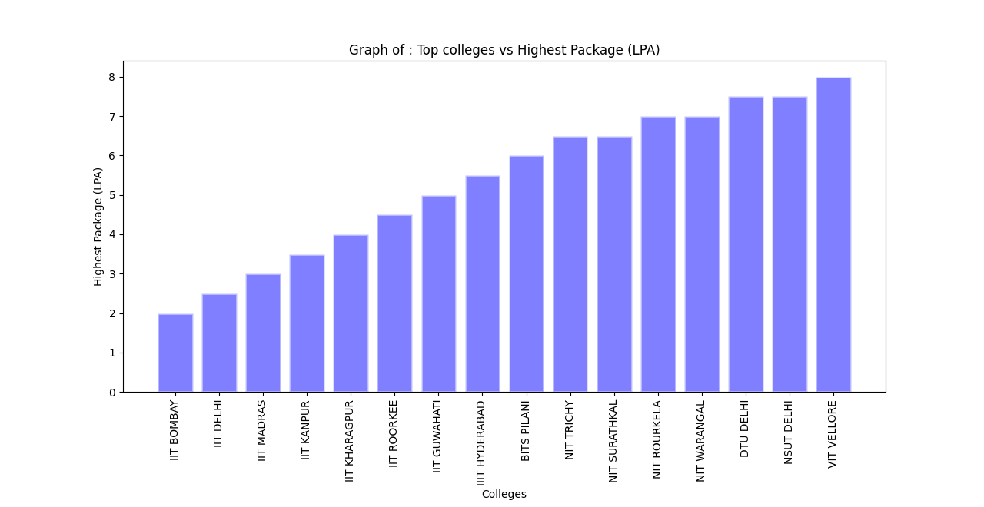
- Graph 2
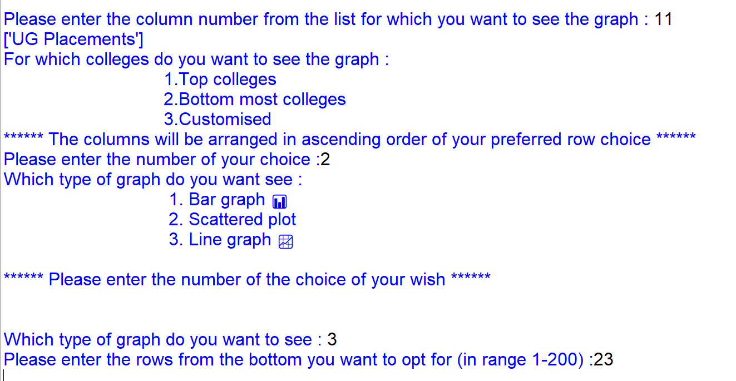
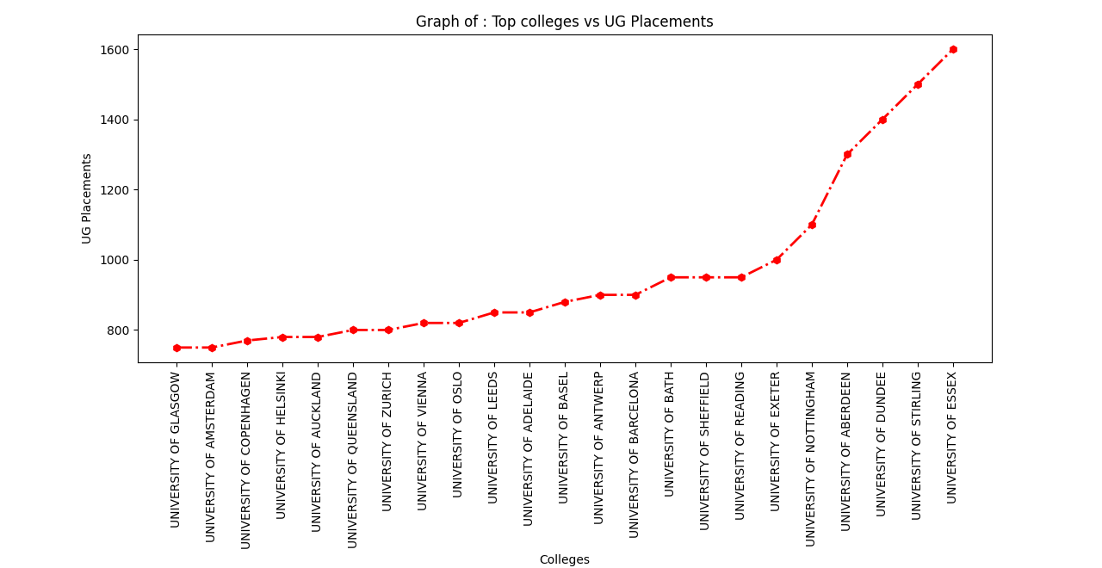

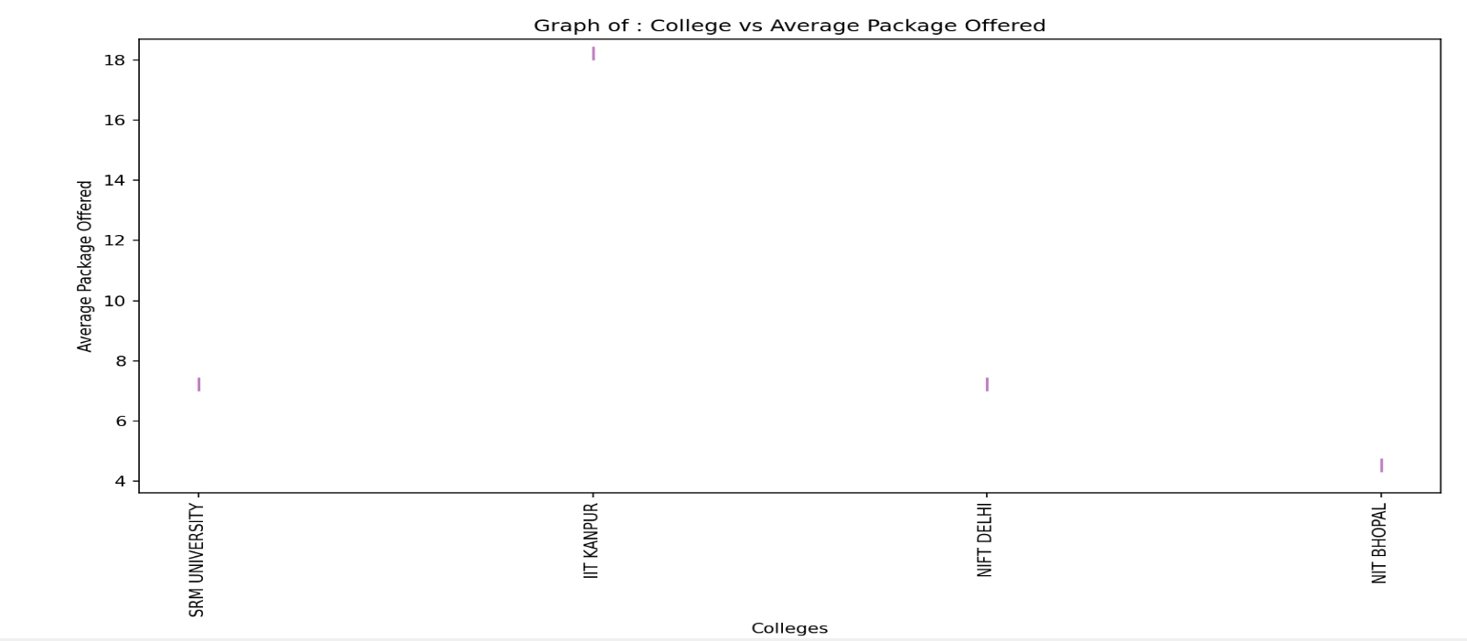
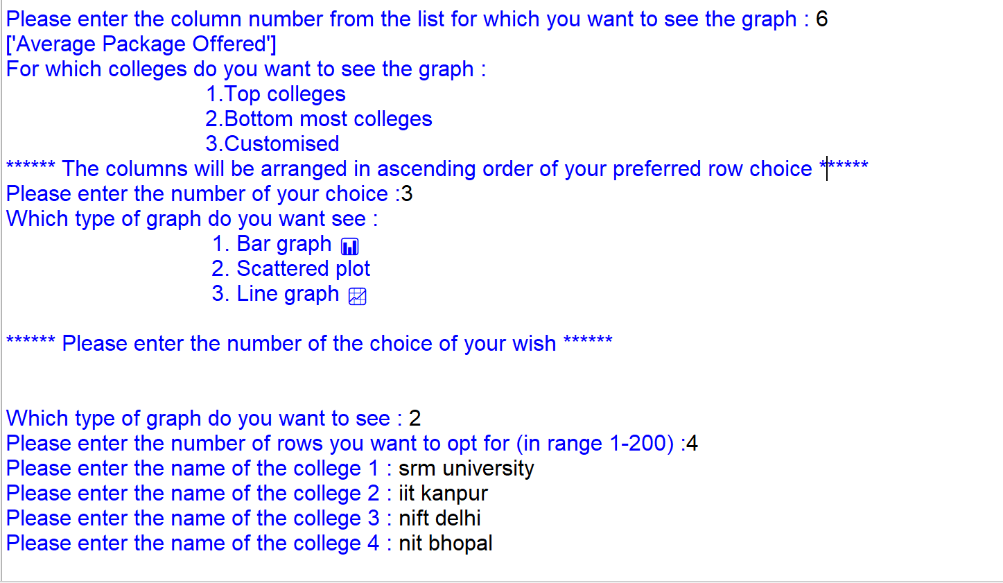
- Graph 3
PROJECT TESTING
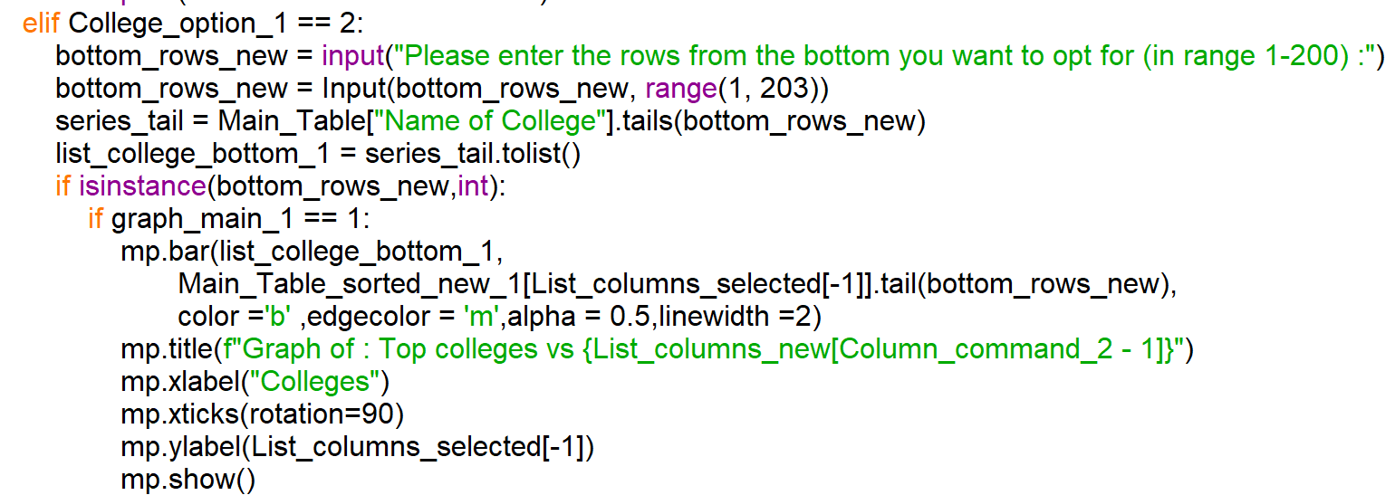
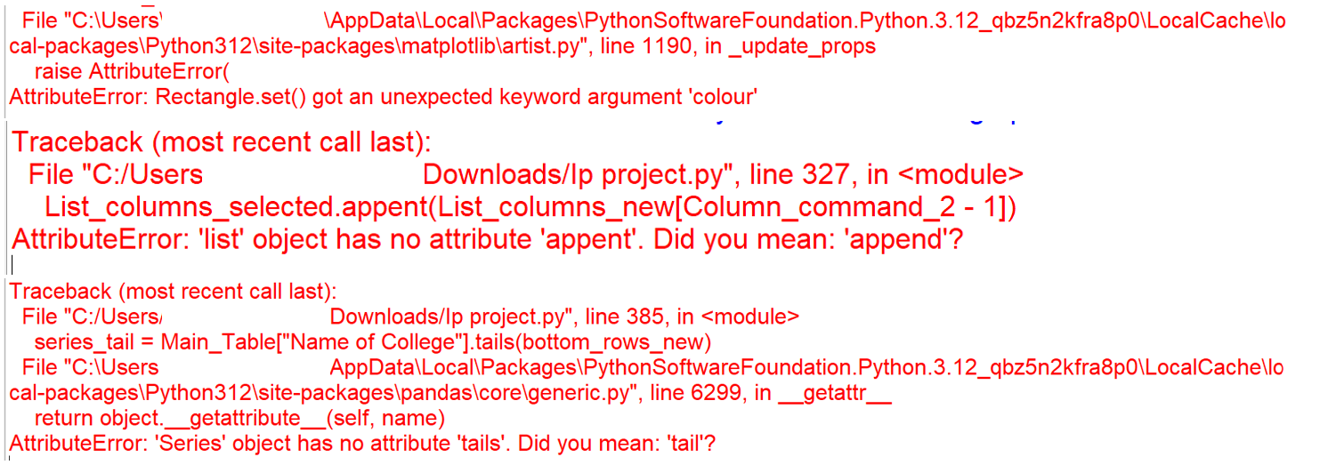

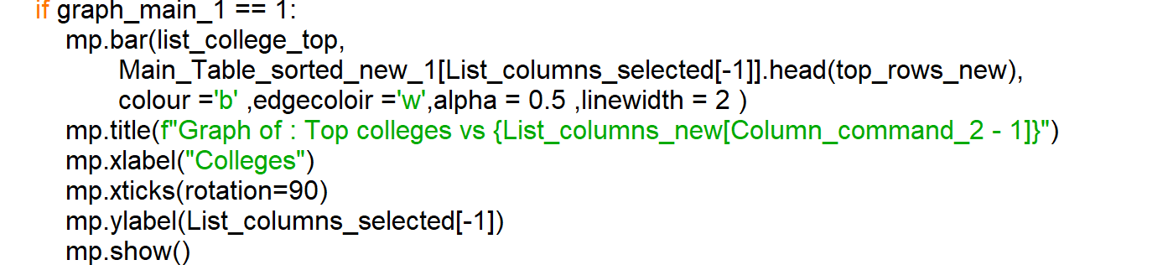

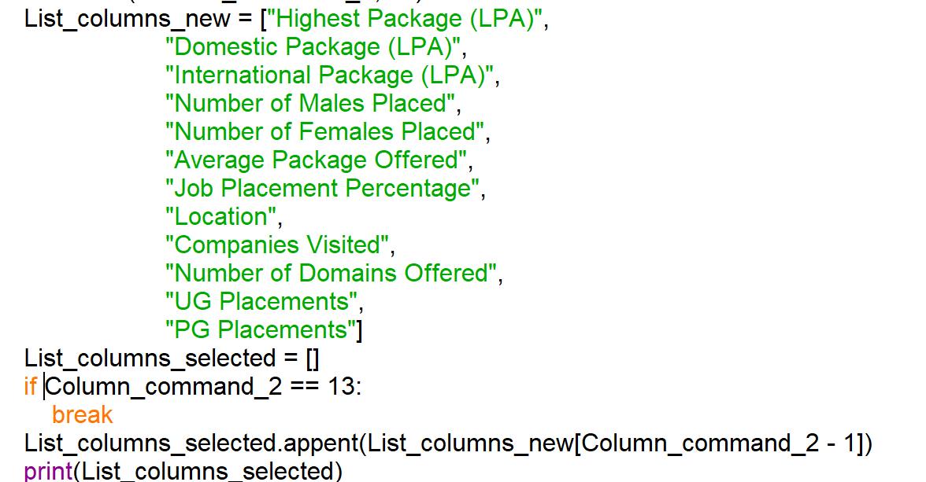

DATA SOURCE
(CSV FILE)

